**User Instructions for Client and Clinician Interfaces**

**Clinician**

**Login:**

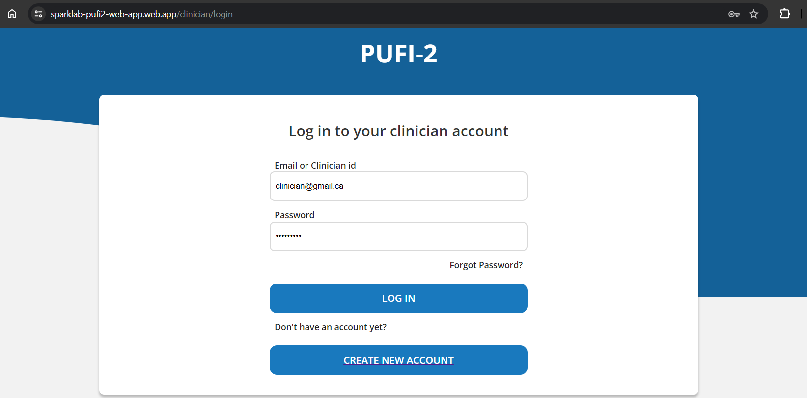

Login page is for clinician login to their account if account is already created. clinician email should be unique address and password should be minimum of 6 digits. If clinician has not created account yet then “Create new account” is available to direct to Register page. After successfully login, clinician will be directed to dashboard. “Forgot password?” link is there for showing information if clinician is not able to login due to password, must contact respective organization to resolve.

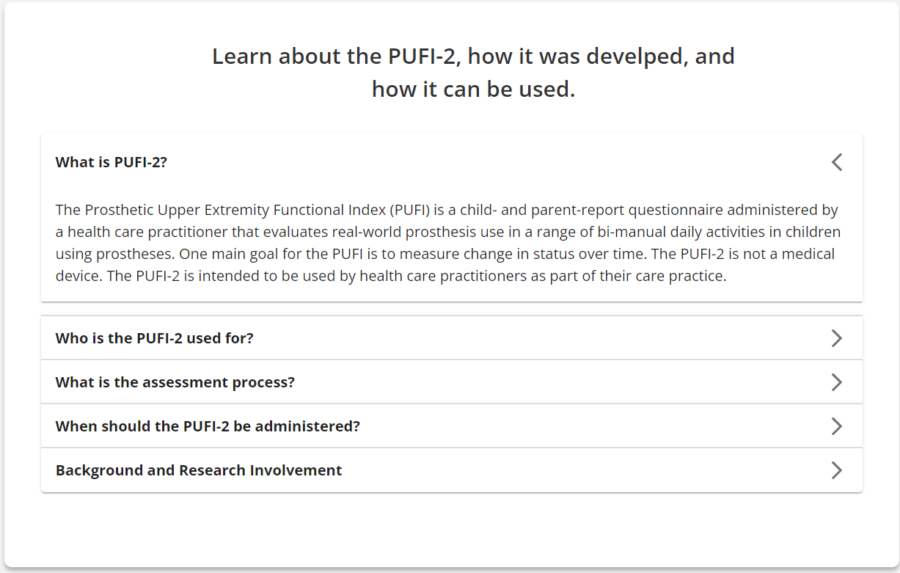

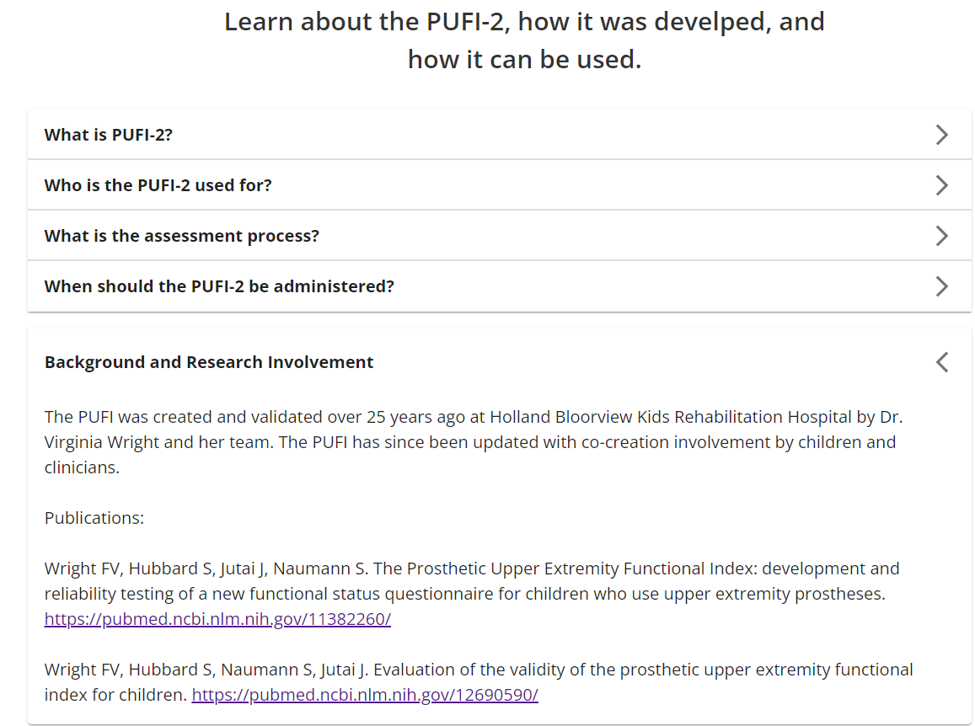

Below login card, clinician will find information card, where all basic F&Q are included. This information are being provided by our sponsors and added to improve clinician experience.

**Register/Create Account:**

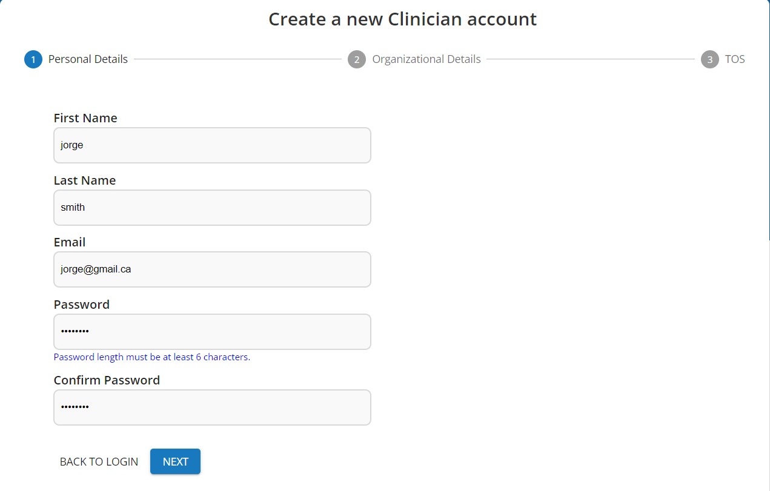

Register clinician is divided into 3 pages, first is “Personal Details” form where all textfields are mandatory and should be right in format. Clinician can move forward with next button.

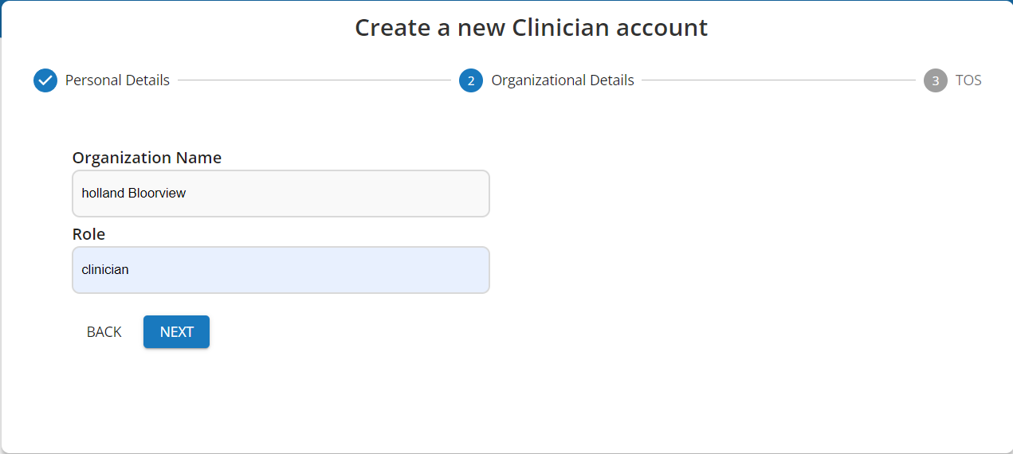

Second page is designed for Organization related information. When clinician will ga back to previous page, will also find prepopulated form with personal details.

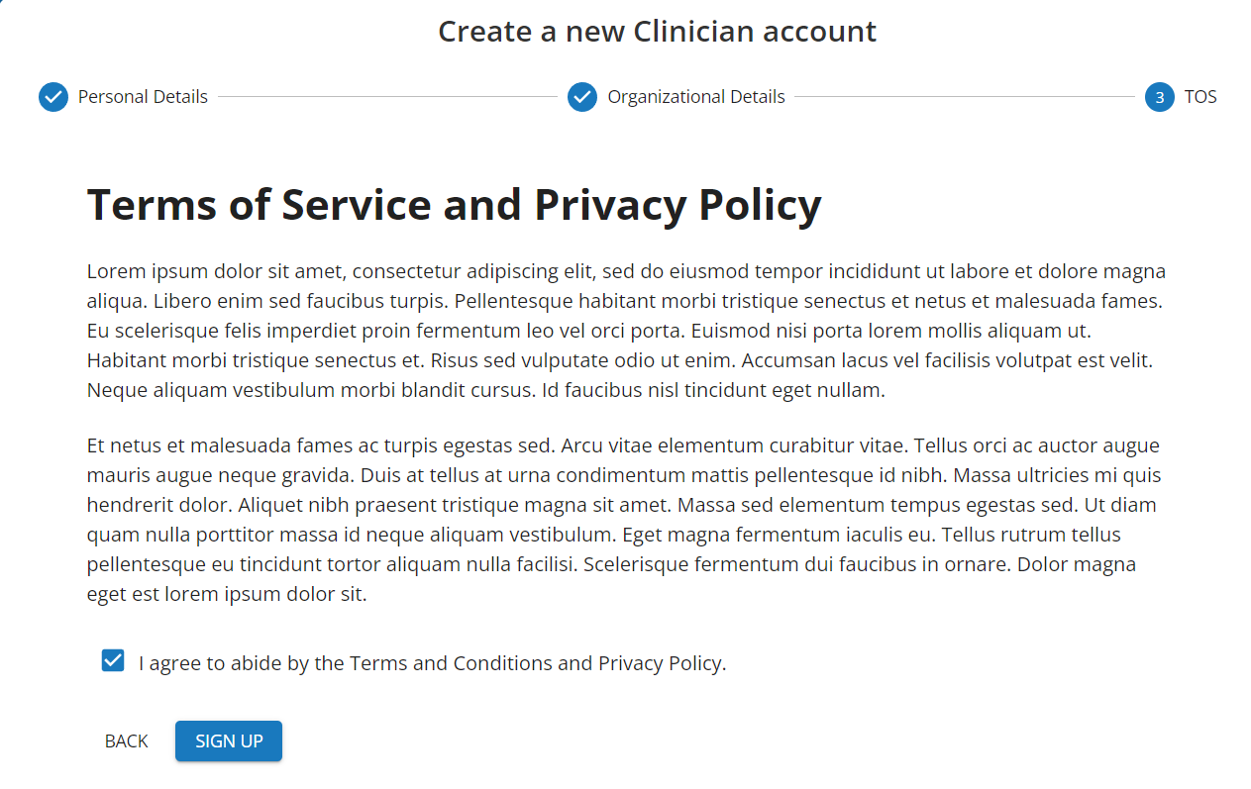

Third step is, Terms Of Service, It is mandatory to accept it to move forward. After this last step, clinician will be redirect to login page to access account. Here there would be same information card such as Login page, so clinicians can review their answers if they have any while register process.

**Navigation:**

On the navigation, the logged-in clinician can open different tabs/pages: Dashboard page, My Clients page, All Questionnaires Page and Help page. As well there is a button to log out.

**Dashboard:**

The dashboard page shows all questionnaires from all clients of the logged-in clinician in a specific format. It shows all questionnaires grouped by questionnaire status: completed (questionnaires that are submitted), in progress (questionnaires that have been started but not submitted yet) and pending (questionnaires that have not been started yet). Near each group of questionnaires, the clinician can see the number of total questionnaires of this status. There is a button called "Add Client” on the page, where the clinician can add a new client.

By clicking on the “View all” button near some specific group of questionnaires, the clinician will be redirected to the All-Questionnaires page with applied filters to see all questionnaires of specified status.

**All Questionnaires:**

All Questionnaires page contains information about all questionnaires the logged-in clinician has from all his clients. There are two tabs: active and archived which show active and archived questionnaires respectively. Note: archived questionnaires are questionnaires that the clinician “removed” but still has access to see these questionnaires and restore them if needed. On the bottom of the page, there is a pagination to navigate through multiple pages of the questionnaires. It can be 9 surveys per page. On the right side, the clinician can see the “Search PUFI-2” button. If you click on it, it will open a **Filter:**

There are a few possible options that clinicians can search for a questionnaire: by Client ID, by Questionnaire Type and Questionnaire Status.

Also, a clinician can search for a questionnaire by the added date of this questionnaire.

After the clinician chooses all the necessary options they want to find a questionnaire they can click the button “Search”. The Applied Filters info box will be visible on the All-Questionnaires page:

Also, there is a “Reset Filter” button, When the clinician clicks on this button, all filter options will be reset and they can see again all questionnaires.

**View Scores:**

Completed and in-progress questionnaires have the option to “View Scores” of the questionnaire. After the clinician clicks on the “View Scores” button they will be redirected to the Summary Scores page, where the clinician can see all diagrams and summarised analysis about the questionnaire they chose to view.

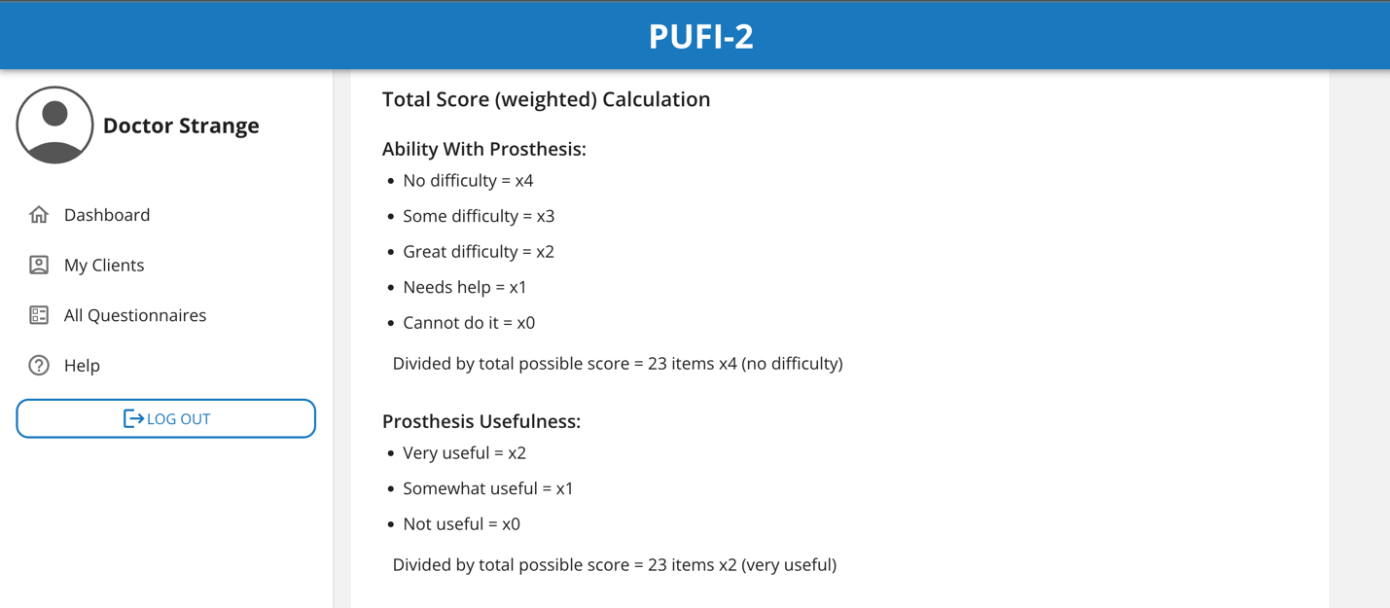

On this page, the clinician can see the proportions of the answers on the questionnaire. Also, the clinician can see the raw table of the data in the “Raw Score” tab:

By clicking on “Download CSV” the clinician will download the questionnaire in the CSV format.

**My Clients:**

This page is intended to show the questionnaires based on the client id, and to add new questionnaires for clients. When we click on “My Clients” button on the left most drawer, we’re presented with this screen where the list of clients is displayed. We can search through this list by client id or use the pagination feature from the bottom of this list to see the next page of clients.

When we click on any client id from the list above, we see questionnaires for that client, and we can again see the next page of questionnaires using the next page button (>) at the bottom-right of this page.

Questionnaires at different stages of completion show different options when the three dots given in that questionnaire information card is clicked:

**Pending Questionnaire** (Red color):

* Email Client: Opens the default email client with pre-filled subject and email body.
* Open PUFI-2: Opens the questionnaire in a new tab.
* Copy PUFI-2 Link: Copies the link of the questionnaire to the clipboard.
* Copy Email Body: Copies the same email body which would be there if “Email Client” was clicked.
* Archive: Archive the questionnaire.

**In-Progress Questionnaire** (Yellow color):

* Send Reminder: Opens the default email client with pre-filled subject and email body.
* Open PUFI-2: Opens the questionnaire in a new tab.
* Copy PUFI-2 Link: Copies the link of the questionnaire to the clipboard.
* Copy Email Body: Copies the same email body which would be there if “Send Reminder” was clicked.
* View Scores: View the diagrams and summarised analysis about the questionnaire.
* Archive: Archive the questionnaire.

**Completed Questionnaire** (Green color):

* View Scores: View the diagrams and summarised analysis about the questionnaire.
* Open PUFI-2: Opens the questionnaire in a new tab.
* Copy PUFI-2 Link: Copies the link of the questionnaire to the clipboard.
* Archive: Archive the questionnaire.

“New Questionnaire” button can be clicked to open Add new questionnaire page where new questionnaire for the selected client can be added.

“Add Client” button can be clicked to open this page where new client can be added by providing a unique client ID.

**Help:**

This button is intended to display information related to how to use the website and some frequently asked questions to help the clinicians.

We’re presented with the heading of the current section of this page and a list of Headers which can be clicked to further reveal relevant information which is contained.

Section can be switched using the given on the top (How to Use, FAQs), and you’ll be presented with similar list in other sections as well:

**Client**

**Home Page:**

Firstly, the client will see the home page. On the home page client can see the information about PUFI-2. Also, there is information about this client and this questionnaire that the client can check if it is correct and ask their clinician to ensure they will fill up the correct questionnaire.

The client can start the questionnaire by clicking on the “Start PUFI-2” Button either at the top of the page or at the bottom of the page. Before the client starts the questionnaire it is recommended to view instructions on how to fill up the questionnaire and what each question type means.

**View Instructions:**

By clicking the “View Instructions” button the client can see the following instructions:

**Survey:**

Click on Start PUFI-2 button to start the survey.

The survey can also be started by clicking on the Start PUFI-2 button in the header.

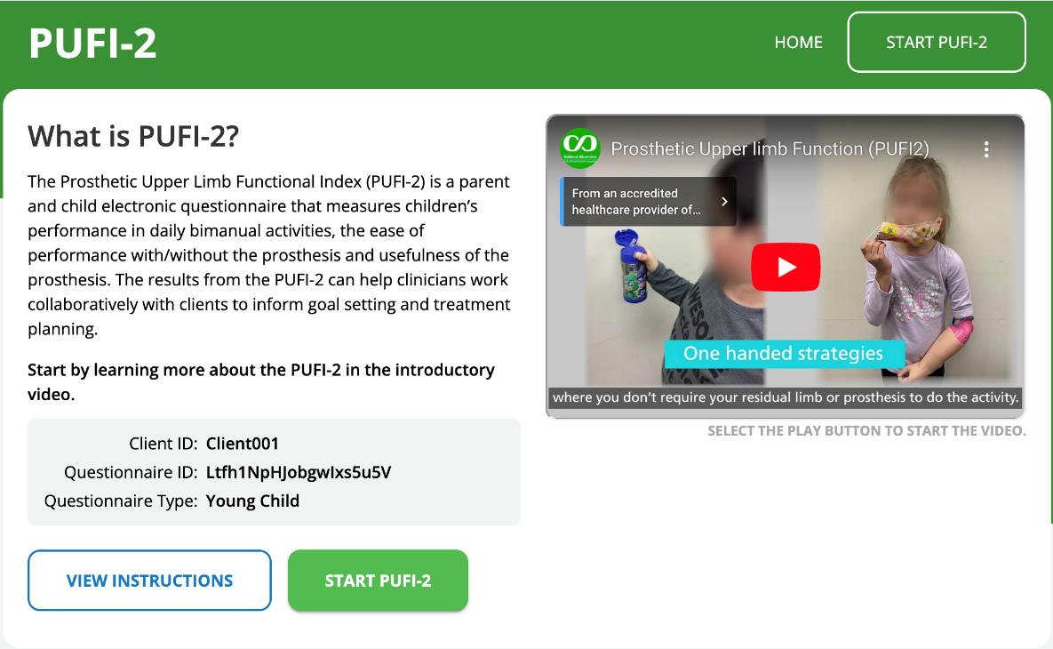

The progress bar and number of activities are at the top and bottom position.

Select the response for the first question by clicking on it.

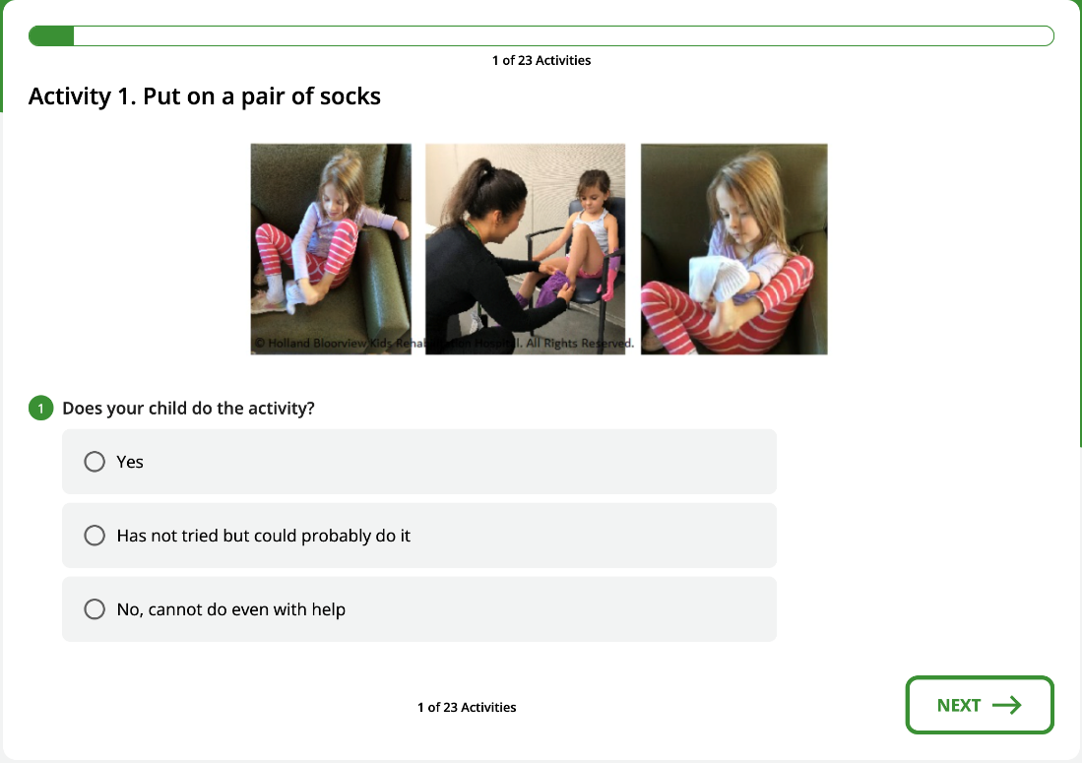

Some questions have additional guide that you can use to help answer the question.

The big button displays the full guide and the button with question mark display a mini guide for each option.

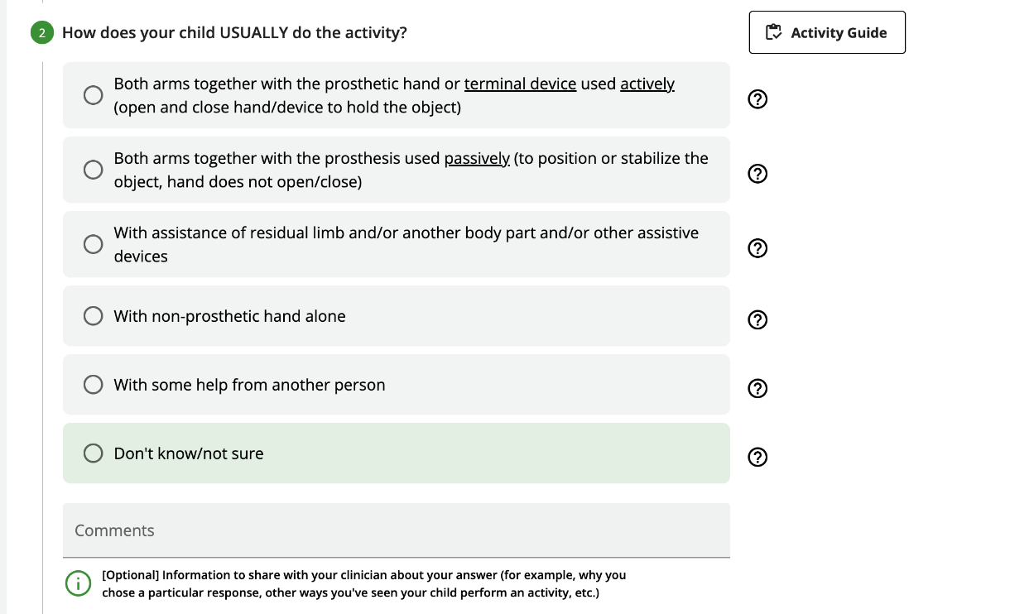

If you select the ‘with assistance of residual limb and/or another body part...’ option, you will have to specify the name of body parts separated by comma in the input area below the options.

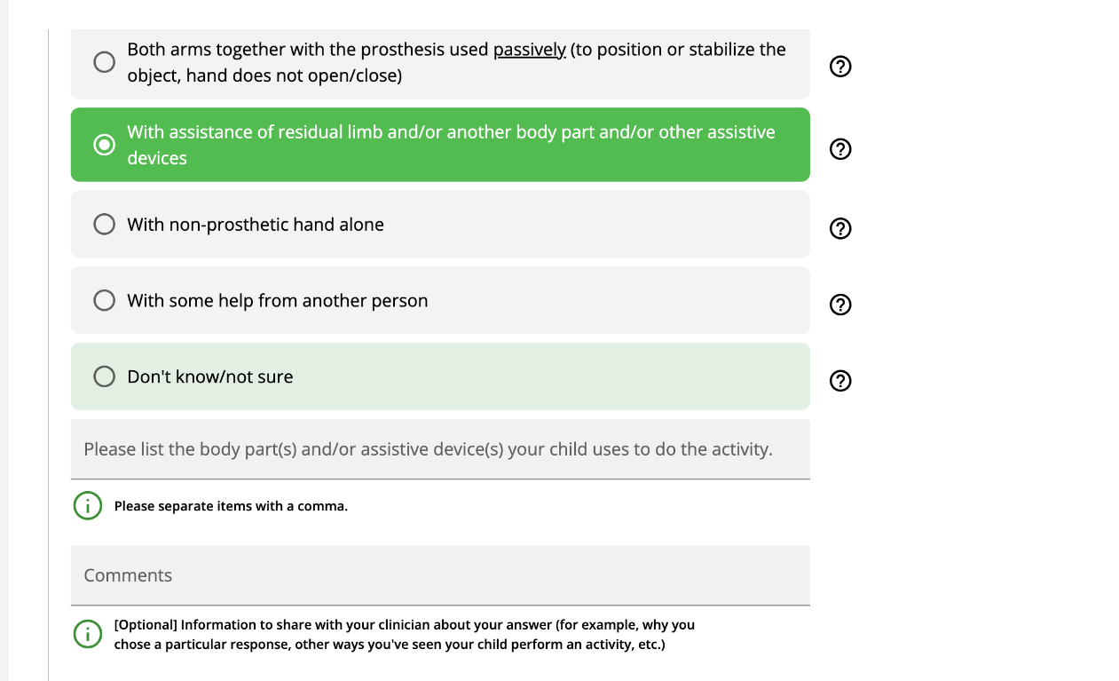

Different questions have different guide associated with them. The guide for this question differs from the guide above.

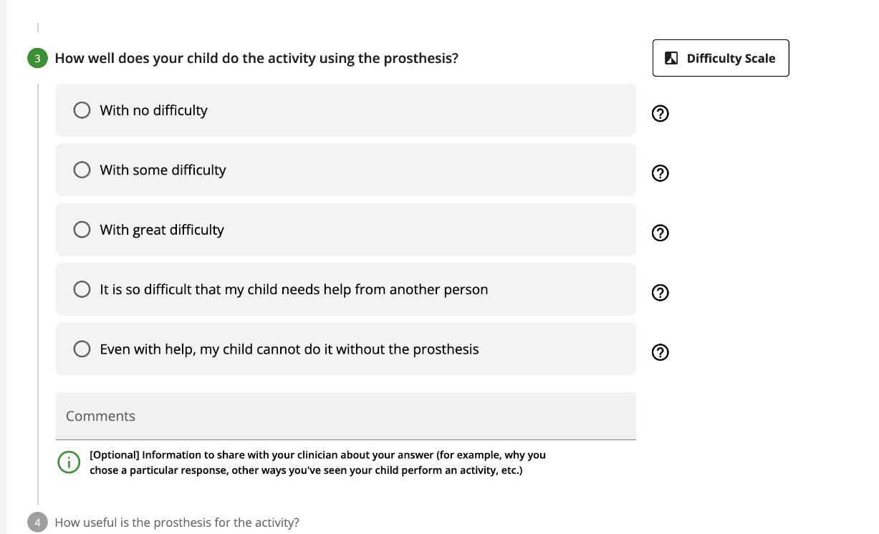

After completing all the questions, click next to go to the next activity.

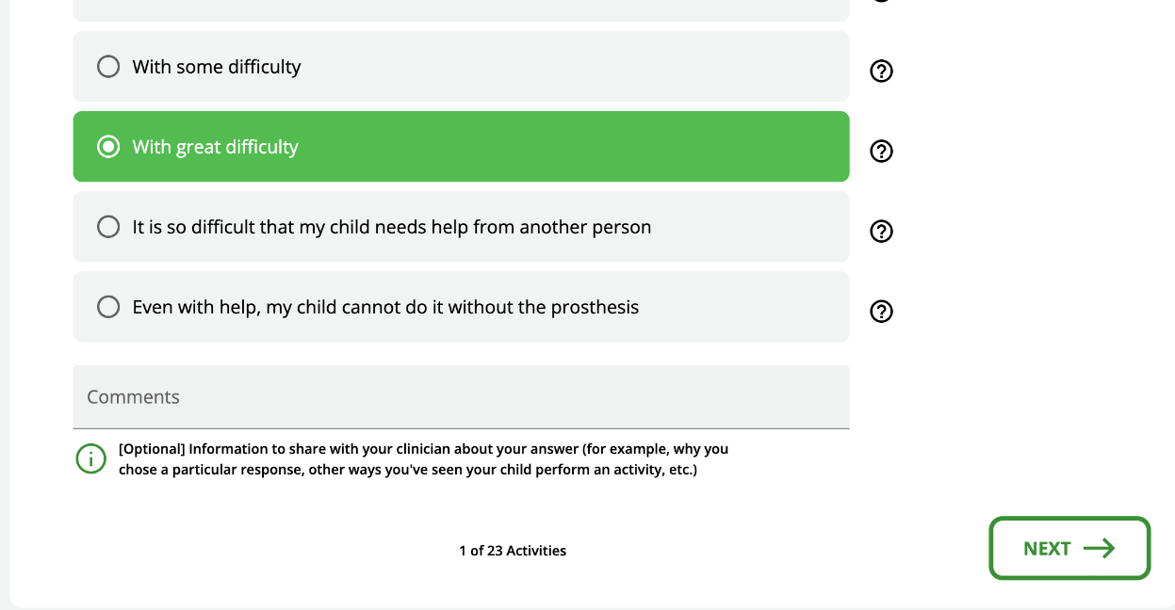

The application guides you with error message if you missed something.

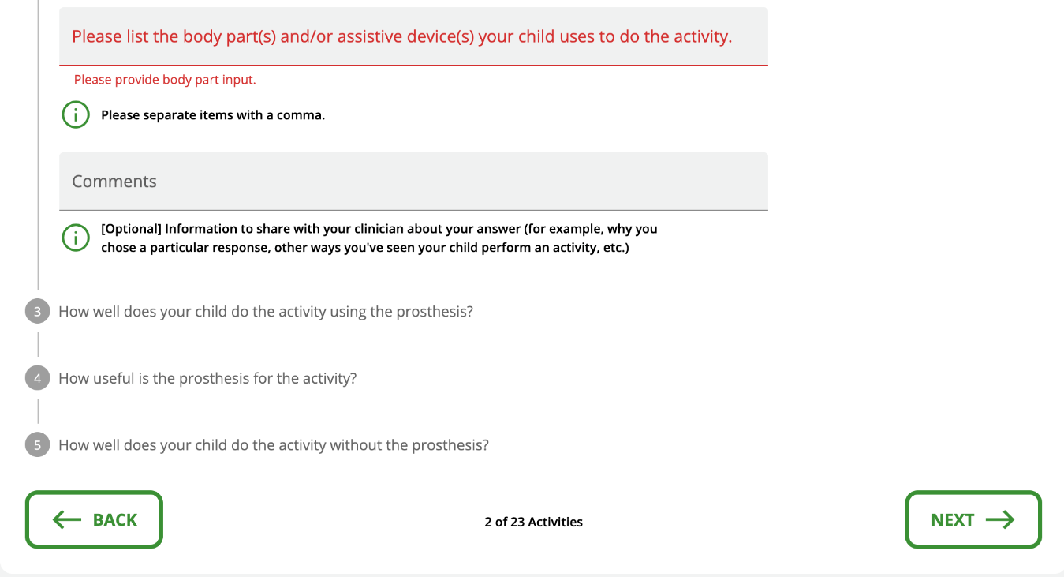

Summary screen;

Once you answer all the activities you reach this summary page where you can see a quick summary of your responses.

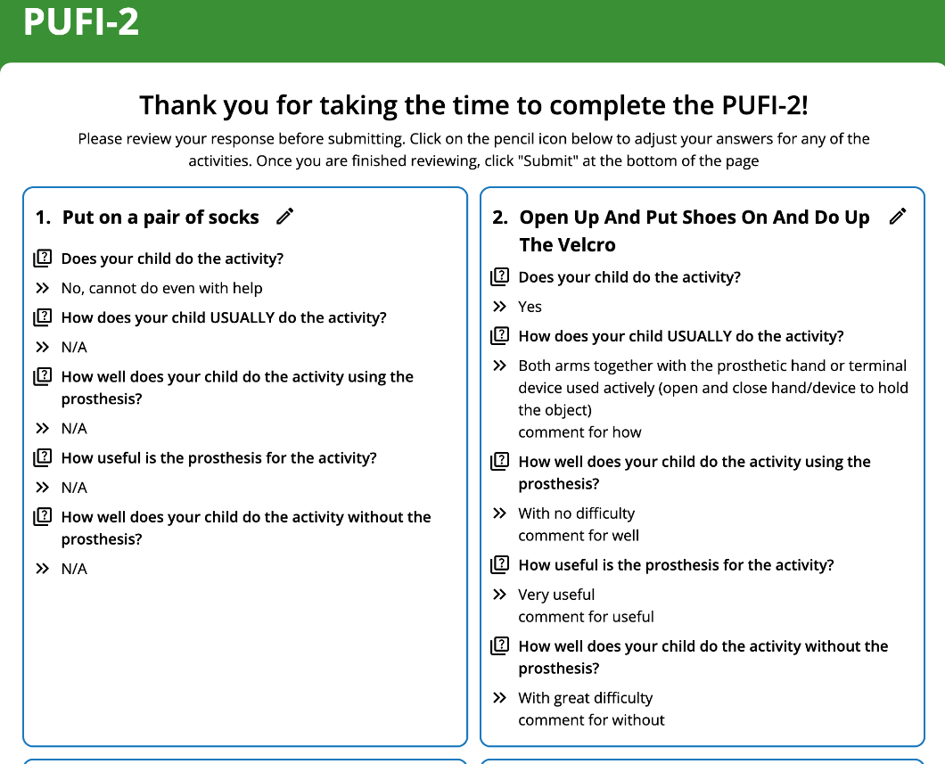

To change a response, you can click on the pen icon, change your response and click ‘save changes’ to save or ‘discard changes’ to discard the change that you made.

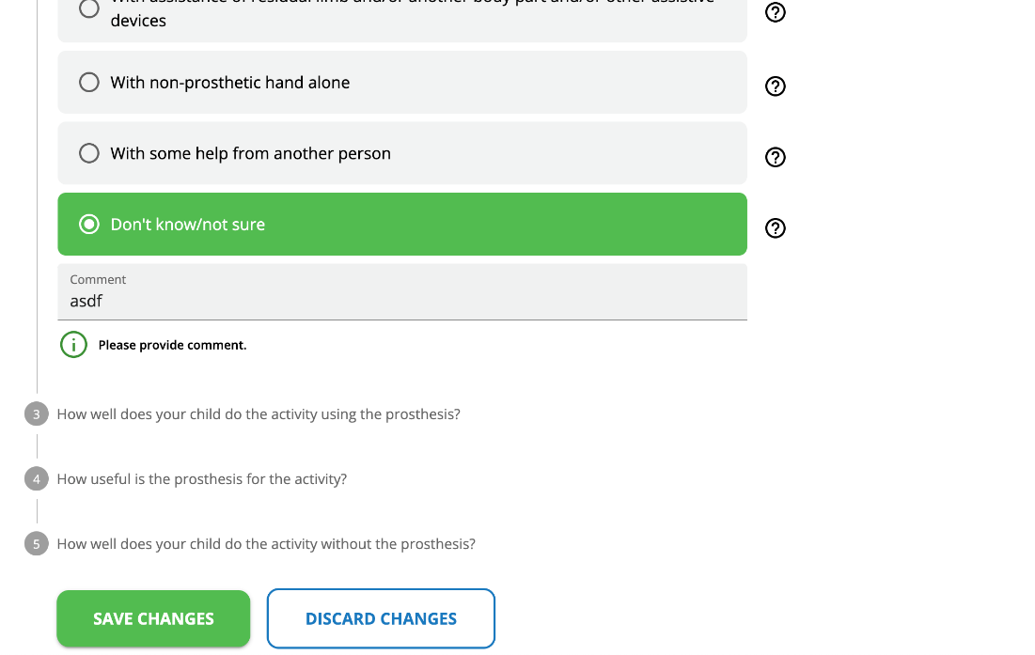

After reviewing your response, you can add a final comment and submit the survey.

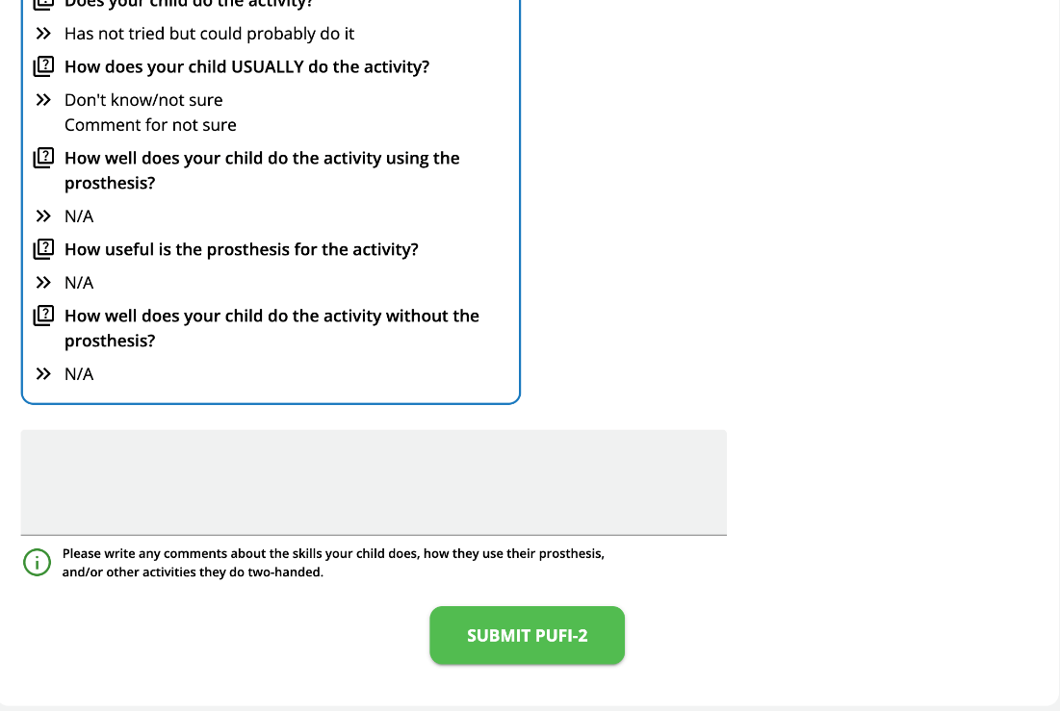

After submitting, you can click on the ‘Download PUFI-2’ button to download a copy of the response.

